ACS – Asian Campus Semester
emlyon business school

ACS will welcome a new cohort this summer starting April 9th 2018 at SHANGHAI.

ACS夏季学期将于2018年4月9号在上海开学。

Are you longing for top business school education?
Are you eager to experience inter-culture?
Join us right here right now!
你想接受世界顶级商学院教育吗？
你想体验跨文化交流环境吗？
赶快加入我们吧！

(分割线)
WHAT IS ACS?
About ACS – Asian Campus Semester:
The ACS programme involves a full range of academic and associated activities to be followed alongside students from emlyon business school (Lyon, France):
Management and Economics Courses
Experiential in-company projects
Careers Workshops
Conferences
Student Association Activities....All of the courses are taught in English.
ACS夏季学期项目：免费提供全方位的学术课程及相关专业活动，全程与来自法国里昂商学院的外籍学生同堂授课！项目内容包括：管理及经济学类课程，企业项目模拟活动，职业规划讲座，学生联谊会…全项目英语授课。
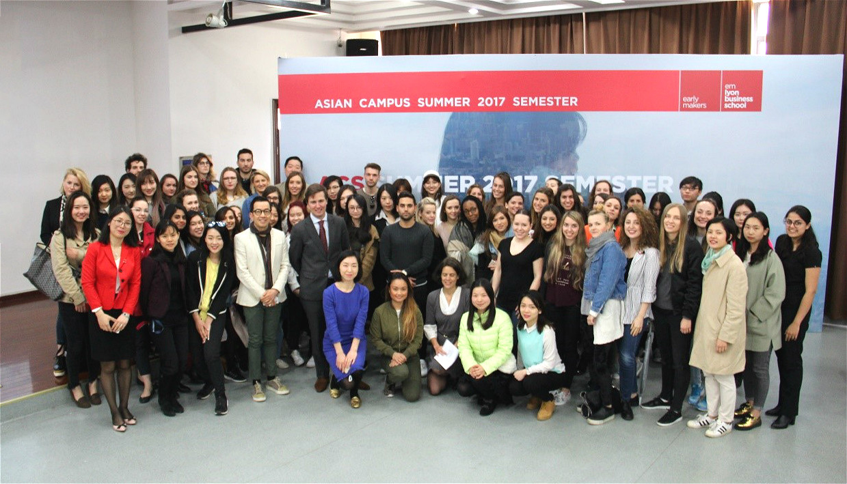



Tuition and Fees: Free of charge!
Language: English
Period: All weekdays from Monday April 9th 2018 to Friday July 27th 2018 (incl.)
Place: emlyon business school Asian Campus, at Zizhu International Education Park, Minhang District (No. 155, Tan jiatang Road)
学费：免费！
授课语言：英语
学期跨度：2018年4月9日—2018年7月27日
地点：上海市闵行区谈家塘路155号，紫竹国际教育园区，里昂商学院亚洲校区。

（分割线）
WHAT ARE THE BENEFITS FOR YOU?
Intercultural Journey at ACS:
About 200 graduate students from emlyon business school, 70% of them are coming from France, 30% other nationalities. 50-60 students from Master’s programmes at first-class universities in China.
ACS跨文化之旅：
约200名来自里昂商学院的在读研究生，其中70%为法国学生，30%其它国家学生50-60名来自我国一流大学的在读研究生。
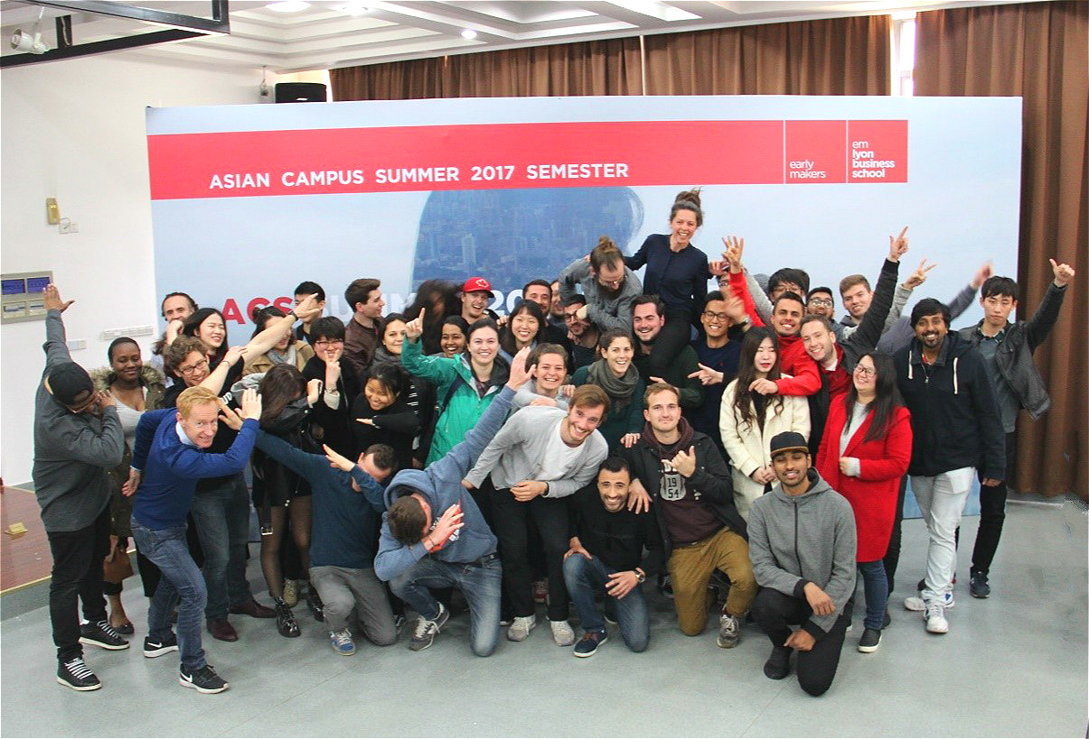

All of the foreign exchange students and Chinese students will take classes together. Furthermore, each Chinese student will be paired with 4 or 5 international students to accomplish the In-company Consulting Project on every Wednesday.
What ACS provides you is not only business courses, but also a good opportunity to experience different cultures, to associate with foreign students.
在ACS学期中，所有中外学生将同堂授课。值得一提的是，每位中国学生将与4-5名国际生组队，共同参与每周三的企业咨询项目模拟活动。
ACS为学生提供的不仅仅是商业课程，更是一个体验跨文化合作，结交国际学生的契机。
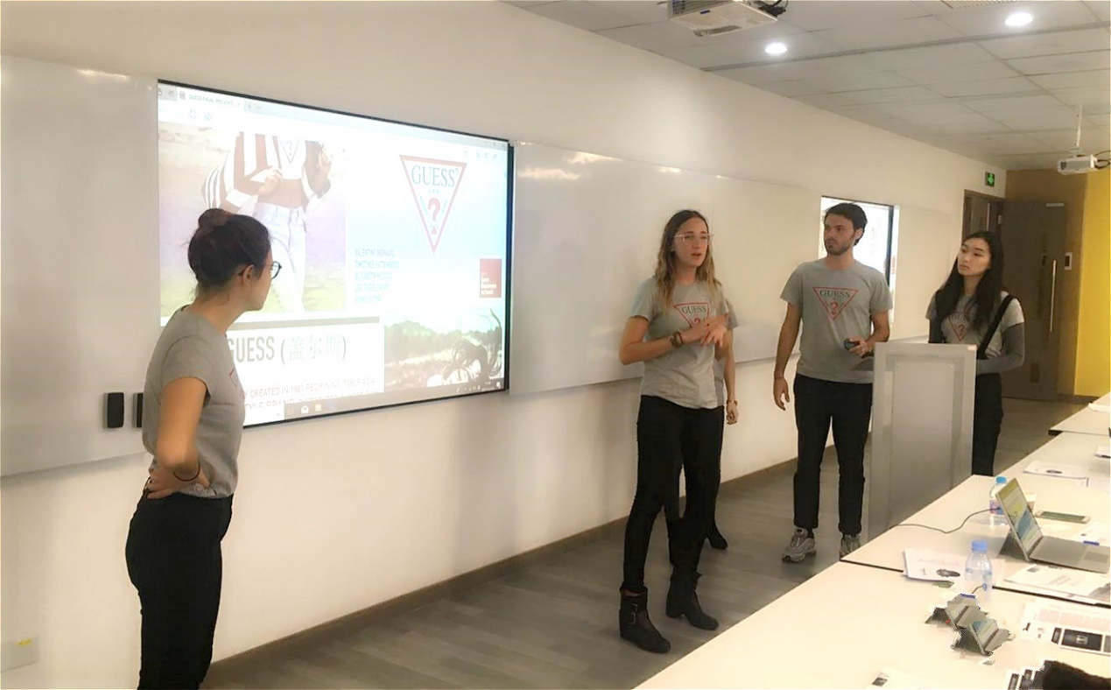
What our ICP Chinese student said:
“ICP project helps us a lot to look into the Chinese booming market. Even for us Chinese students, it is truly exciting and helpful for us to jump out of the box and see the status quo from the other perspectives. We know better China then. As for its impact to future occupation or career, it provides me, a student from non-business-related major, a good chance initially to learn and practice at the same time which is one of the best ways to get to know something new from my viewpoint.”

（分割线）

WHOM WE ARE LOOKING FOR?
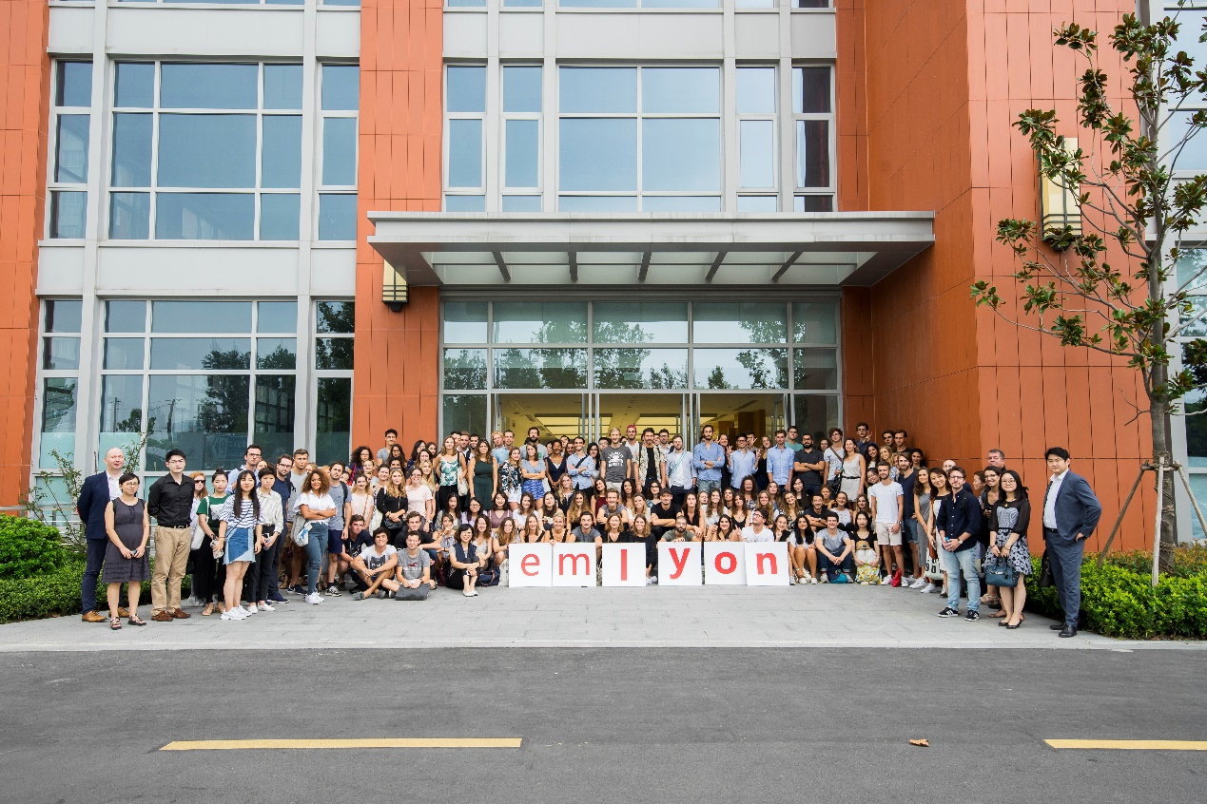

1. Chinese students enrolled in a Master’s programme.
(Undergraduate Students who are in their fourth year will also be taken into consideration.)
硕士在读的中国学生。（也会考虑本科四年级在读中国学生。）

2. They should hold a first qualification in the fields of Social Sciences or Management or in related fields (e.g. Law, Economics, Finance, Project Management, International Trade, Tourism Management, Information Science, etc.)
专业要求：社会科学或管理学等相关领域（法律、经济、金融、项目管理、国际贸易、旅游管理、信息科学等）

3. Good written and oral skills in English, be able to communicate with international students.
良好的英语能力，能够顺利与外国教授、学生交流。

4. The students who take their studies and their future seriously, and be able to attend all of the courses and activities.
学习态度认真，重视自己的未来规划，并能确保出席所有课程及活动。

（分割线）

HOW TO APPLY FOR ACS？
STEP 1: Scan QR Code, Join Our QQ Group / Group NO. 514650129 (ACS 2018 Summer Admission)
STEP 2: Download Application Form
STEP 3: Send Your Application Form to jia@em-lyon.com
STEP 4: Interview
Application deadline: Dec.31st 2017 (1st deadline), Jan.7th 2018 (2nd deadline)

- 扫二维码或者搜索群号514650129 (ACS 2018 Summer Admission)加入QQ群
- 下载申请表
- 将申请表发送至邮箱：zhu@em-lyon.com
- 面试
申请截止：2017年12月31日（第一批报名截止），2018年1月7日（第二批报名截止）

QQ群号: 514650129
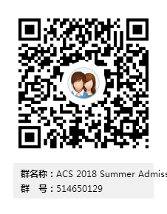

(分割线)

About emlyon business school:
emlyon business school was founded in 1872 by the Lyon Chamber of Commerce and Industry. It is one of Europe’s leading business schools and holds the triple accreditation Equis, AACSM and AMBA.
里昂商学院于1872年由法国里昂工商业联合会创立，是一所欧洲顶尖的精英学院，同时也是世界上少数同时获得三大国际组织认证的商学院之一（EQUIS, AACSB, and AMBA）。

Key Figures of emlyon business school:
TOP 4 Business School in France
Top 1 Incubator in France
Top 26 in Global Employability, Top 2 in France
5 campuses: LYON • SHANGHAI • SAINT-ETIENNE • CASABLANCA • PARIS
5,100 students in Graduate Programmes
5,500 participants per year in Executive Education Programmes
29,000 Alumni in 118 countries
50% of Faculty with an international profile representing 18 nationalities
主要数据：
法国排名前4商学院
法国排名第1企业孵化器
全球就业力第26名，全法第2
五大校区：里昂，上海，圣埃蒂安，卡萨布兰卡，巴黎
5,100名在读研究生
每年5,500名高层管理教育项目参与者
29,000名校友涵盖全球118个国家
50%教师具有国际背景且来自18个国家

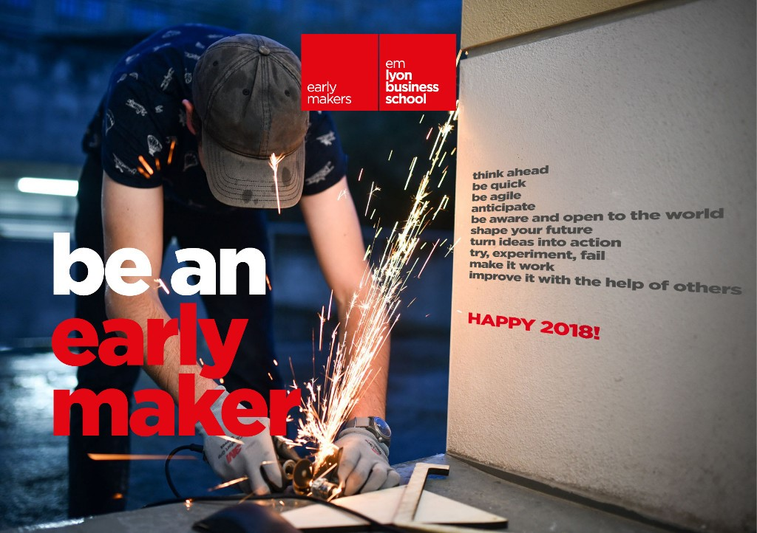

I wake up early.
I capture a thousand
ideas, shake and share them,
focus and turn good ones
into opportunities.
I move forward to make it
happen, try, fail, do it again,
make it work and improve it
with the help of others.
我很早就醒来。
上千的想法跃过脑海
激荡，共享，
我着力，将好的创意
转变为机遇。
不断前进，变其为现实
尝试、失败、重新再来，
实践、改进，
与他人协作。

I am more than an entrepreneur.
I am a maker.
我，不只是有创新精神的人，
更是一个创客。

